Keypasser / Password Manager

Merc keypasser / Key Master

# Functionalities

* Insert data (Password, Username, source)
* Generate Password
* In insert data use standard username (Maybe generate random username based on the username to login)
* Log in / sign up function
* Log out after max inactivity time has passed
* The list can have icons
* Dark mode

Design possibility

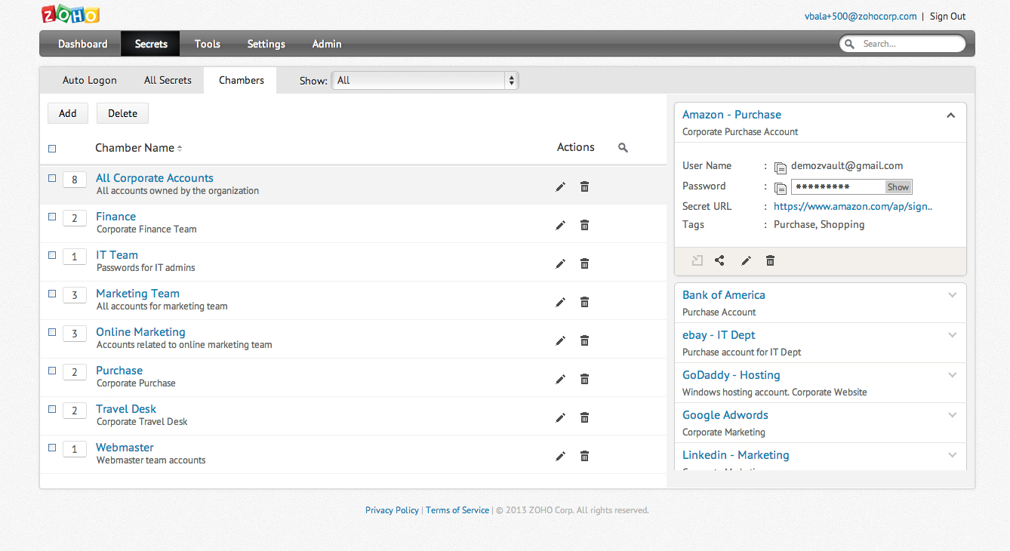

# Task List

|  |  |
| --- | --- |
| Task name | Time (hours) |
| Make a GitHub repo | 0.5 |
| Readme file | 5 |
| Documentation | 7.5 |
| Frontend |  |
| Create structure for Login page | 3.5 |
| Create structure for Main page | 3.5 |
| Design Title bar | 5 |
| Design Login page | 5 |
| Design Sign up form | 5 |
| Design Main page | 5 |
| Design Create form | 5 |
| Icon / pictures | 3.5 |
| Light / Dark mode | 4 |
| Backend |  |
| Set up server | 7.5 |
| Set up database | 3.5 |
| Test data for database | 2 |
| Api (Make / Call) |  |
| Insert data | 3.5 |
| Get data | 3.5 |
| Delete data | 3.5 |
| Edit data | 3.5 |
| get icon / pictures | 3.5 |
| Log in / out functionality | 7.5 |
| Sign up functionality | 7.5 |
| Timeout functionality | 7.5 |
| Password generator | 7.5 |
| Test you stuff works | 22.5 |